1.**Program to check if a given number is Positive, Negative, or Zero.**

import java.util.*;

class Main {

public static void main(String[] args) {

Scanner in = new Scanner(System.in);

System.out.println("Enter the number: ");

int n = in.nextInt();

if (n > 0){

System.out.println("The given number is positive");

}

else if (n == 0){

System.out.println("The given number is zero");

}

else{

System.out.println("The given number is negative");

}

}

}

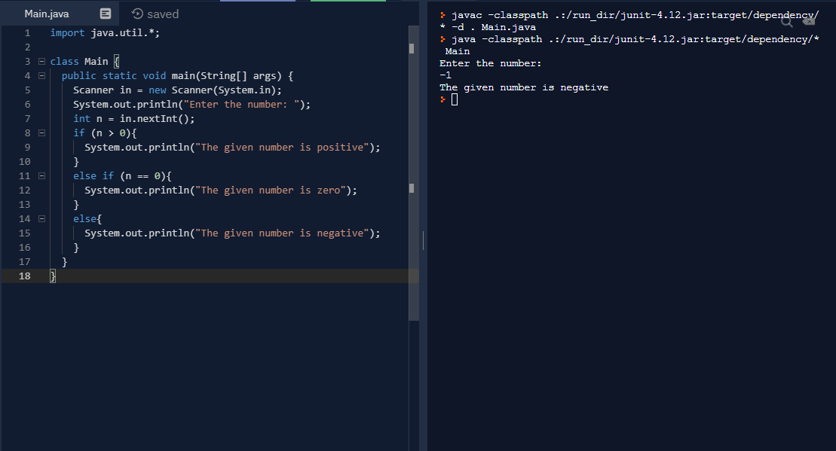

**2. Program to check if a given number is odd or even.**

import java.util.*;

class Main {

public static void main(String[] args) {

Scanner in = new Scanner(System.in);

System.out.println("Enter the number: ");

int n = in.nextInt();

if (n % 2 == 0){

System.out.println("The given number is even");

}

else{

System.out.println("The given number is odd");

}

}

}

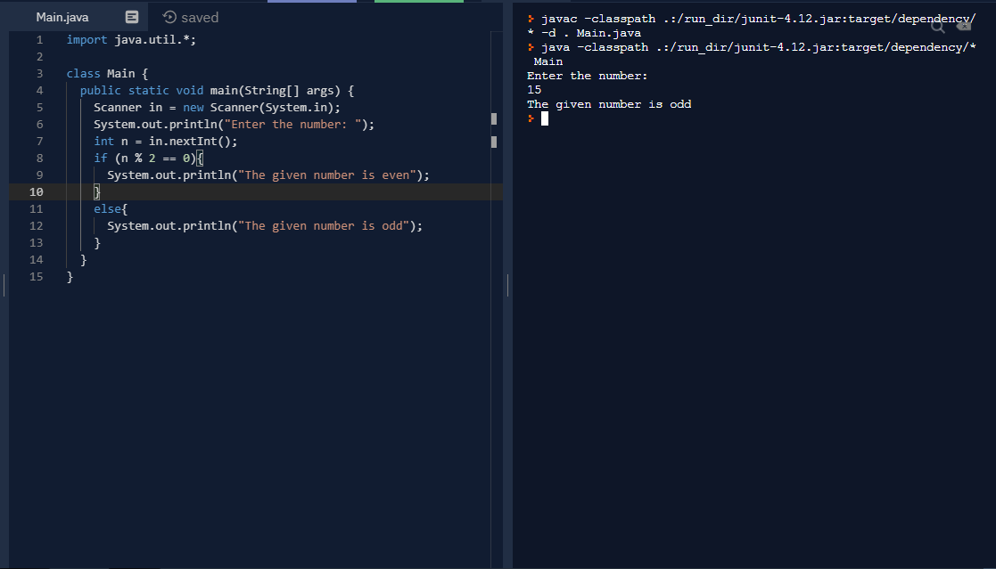

**3. Program to check if the program has received command line arguments or not.**

public class Main {

public static void main(String[] args) {

if (args.length == 0){

System.out.println("No values");

System.exit(0);

}

else{

for(int i = 0; i < args.length; i++){

System.out.print(args[i] + ',');

}

}

}

}

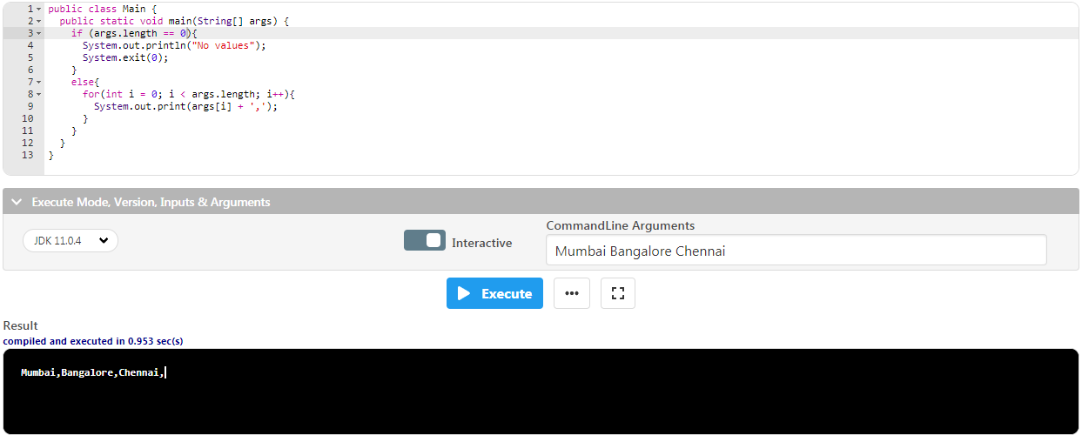

**4. Initialize two character variables in a program and display the characters in alphabetical order.**

import java.util.*;

public class Main{

public static void main(String[] args){

Scanner in = new Scanner(System.in);

System.out.println("enter the first character");

char ch1 = in.next().charAt(0);

System.out.println("enter the second character");

char ch2 = in.next().charAt(0);

if (ch1 > ch2)

System.out.println(ch2 + "," + ch1);

else

System.out.println(ch1 + "," + ch2);

}

}

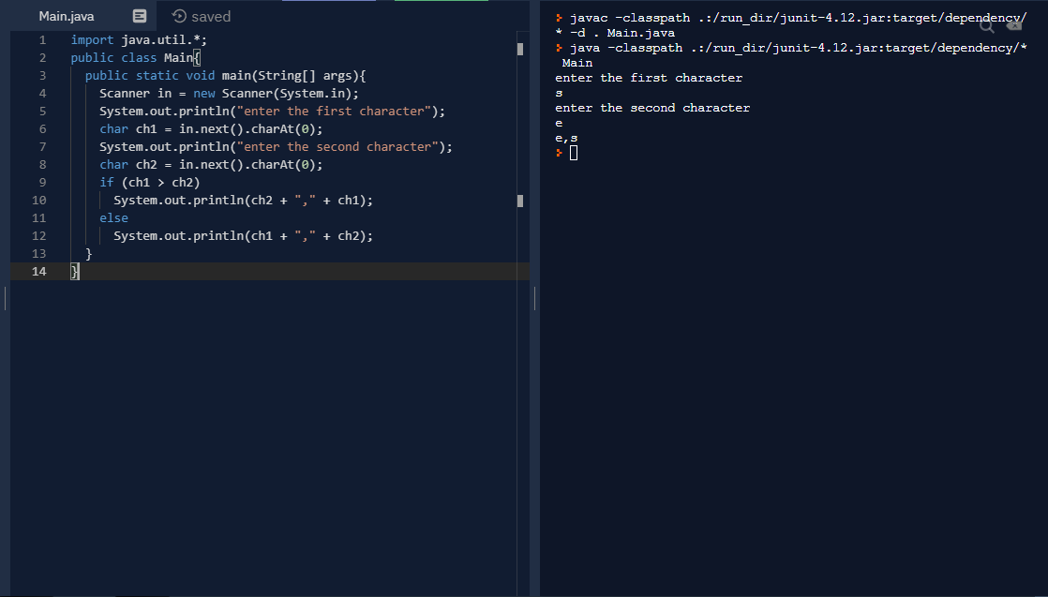

**5. Initialize a character variable in a program and if the value is alphabet then print "Alphabet" if it’s a number then print "Digit" and for other characters print "Special Character"**

import java.util.*;

public class Main {

public static void main(String args[]){

System.out.print("Enter a element: ");

Scanner in = new Scanner(System.in);

char char1 = in.next().charAt(0);

if(char1 >= 48 && char1 <= 57){

System.out.print("The given element is Digit");

}

else if((char1 >= 'a' && char1 <= 'z') || (char1 >= 'A' && char1 <= 'Z')){

System.out.print("The given element is Alphabet");

}

else{

System.out.print("The given element is special character");

}

}

}

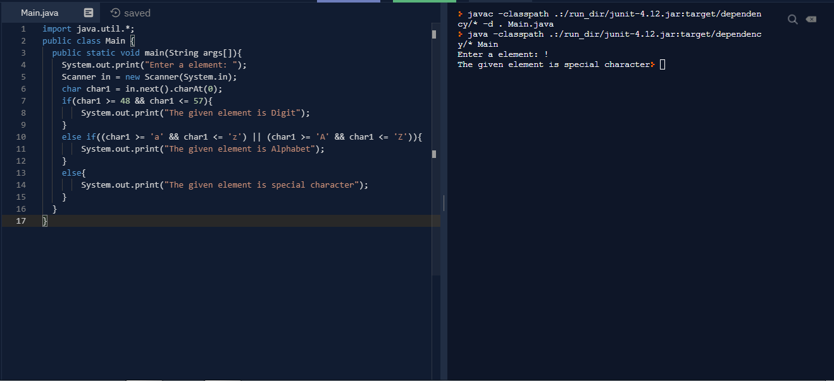

**6. Program to accept gender ("Male" or "Female") and age (1-120) from command line arguments and print the percentage of interest based on the given conditions.**

public class Main {

public static void main(String[] args) {

String gender = args[0];

int age = Integer.parseInt(args[1]);

if(gender.equalsIgnoreCase("Female")){

if(age >= 1 && age <= 58){

System.out.println("Interest = 8.2%");

}

else if(age > 58 && age <= 120){

System.out.println("Interest = 7.6%");

}

}

else{

if(age >= 1 && age <= 60){

System.out.println("Interest = 9.2%");

}

else if(age > 60 && age <= 120){

System.out.println("Interest = 8.3%");

}

}

}

}

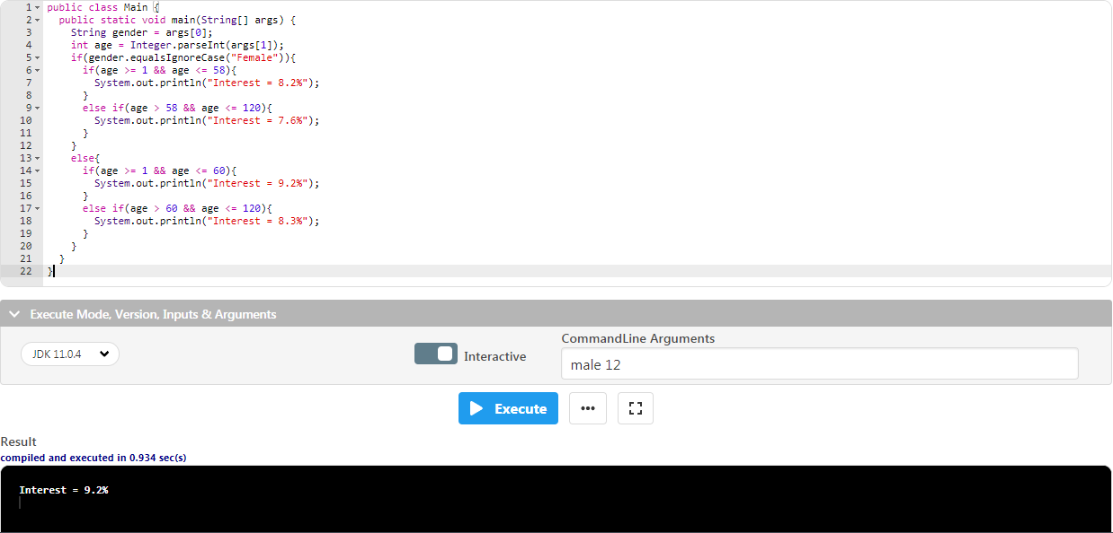

**7.** **Program to convert from upper case to lower case and vice versa of an alphabet and print the old character and new character as shown in example (Ex: a->A, M->m).**

import java.util.*;

class Main {

public static void main(String[] args) {

Scanner in = new Scanner(System.in);

char ch = in.next().charAt(0);

if(Character.isLowerCase(ch))

System.out.println(ch + " -> " + Character.toUpperCase(ch));

else

System.out.println(ch + " -> " + Character.toLowerCase(ch));

}

}

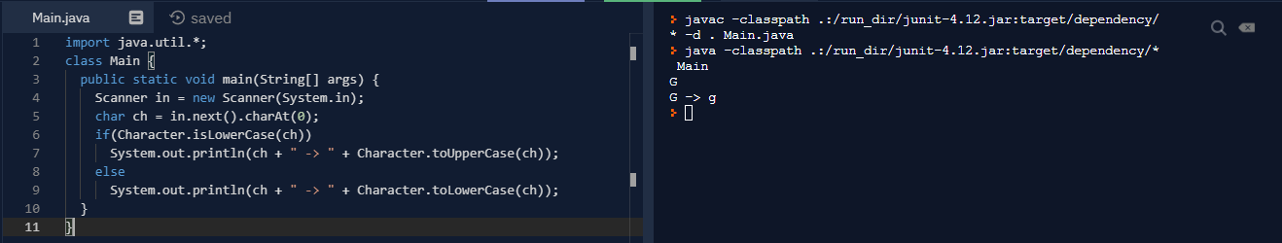

**8.Program to** **print the color name, based on color code. If color code in not valid then print "Invalid Code". R->Red, B->Blue, G->Green, O->Orange, Y->Yellow, W->White.**

import java.util.*;

class Main {

public static void main(String[] args) {

Scanner in = new Scanner(System.in);

char ch = in.next().charAt(0);

switch (ch) {

case 'R': System.out.println("R -> Red");

break;

case 'G': System.out.println("G -> Green");

break;

case 'B': System.out.println("B -> Blue");

break;

case 'O': System.out.println("O -> Orange");

break;

case 'Y': System.out.println("Y -> Yellow");

break;

case 'W': System.out.println("W -> White");

break;

default: System.out.println("Invalid");

}

}

}

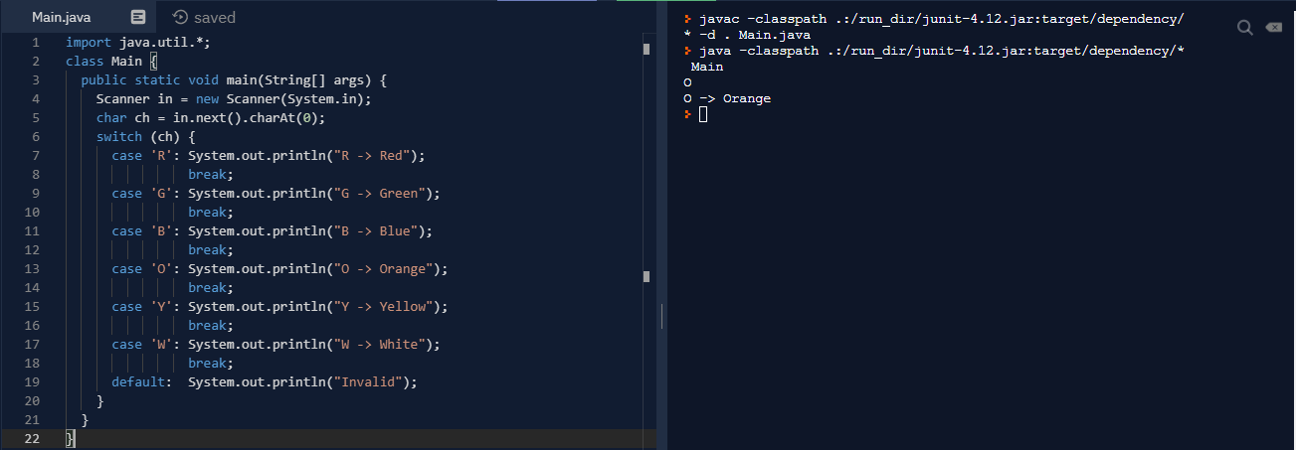

**9.** **Program to print month in words, based on input month in numbers.**

public class Main {

public static void main(String[] args) {

if (args.length == 0)

System.out.println("Please enter the month in numbers");

System.exit(0);

switch (args[0]) {

case "1": System.out.println("January");

break;

case "2": System.out.println("Febuary");

break;

case "3": System.out.println("March");

break;

case "4": System.out.println("April");

break;

case "5": System.out.println("May");

break;

case "6": System.out.println("June");

break;

case "7": System.out.println("July");

break;

case "8": System.out.println("August");

break;

case "9": System.out.println("September");

break;

case "10": System.out.println("October");

break;

case "11": System.out.println("November");

break;

case "12": System.out.println("December");

break;

default: System.out.println("Invalid month");

}

}

}

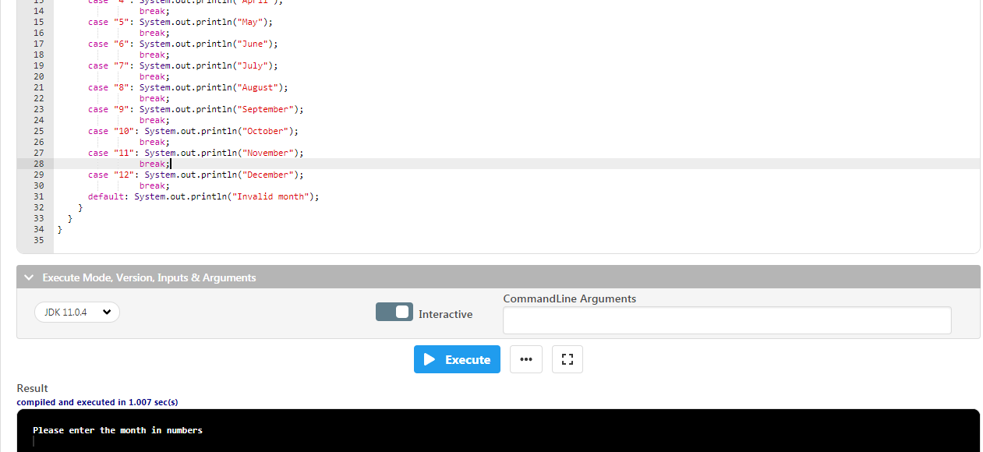

**10.** **Program to print numbers from 1 to 10 in a single row with one tab space.**

class Main {

public static void main(String[] args) {

for(int i = 1; i <= 10; i++){

System.out.print(i + "\t");

}

}

}

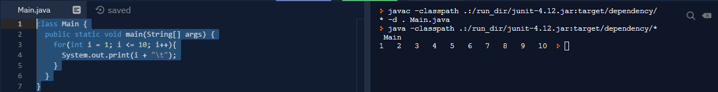

**11.** **Program to print even numbers between 23 and 57, each number should be printed in a separate row.**

class Main {

public static void main(String[] args) {

for(int i = 23; i <= 57; i++){

if(i % 2 == 0)

System.out.println(i);

}

}

}

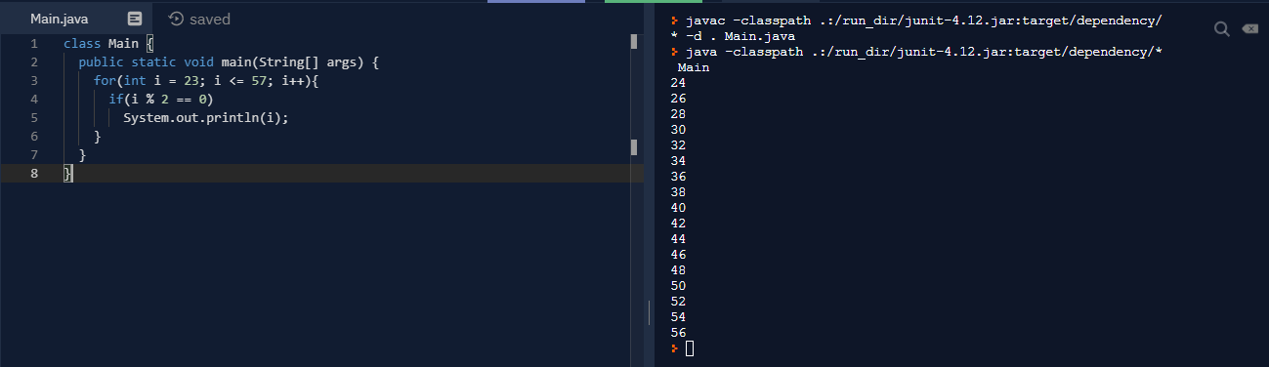

**12.** **Program to check if a given number is prime or not.**

import java.util.*;

class Main {

public static void main(String[] args) {

Scanner in = new Scanner(System.in);

int n = in.nextInt();

boolean flag = false;

for(int i = 2; i <= n/2; i++){

if(n % i == 0){

flag = true;

break;

}

}

if(!flag)

System.out.println(n + " is a prime number");

else

System.out.println(n + " is not a prime number");

}

}

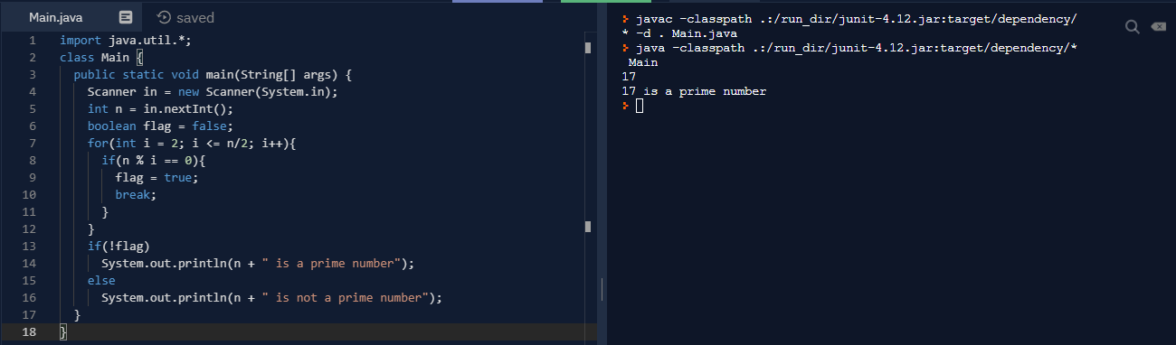

**13.** **Program to print prime numbers between 10 and 99.**

class Main {

public static void main(String[] args) {

int temp, i;

for(i = 10; i <= 99; i++){

temp = 0;

for(int j = 2; j < i; j++){

if (i % j == 0){

temp = 1;

break;

}

}

if(temp == 0)

System.out.println(i);

}

}

}

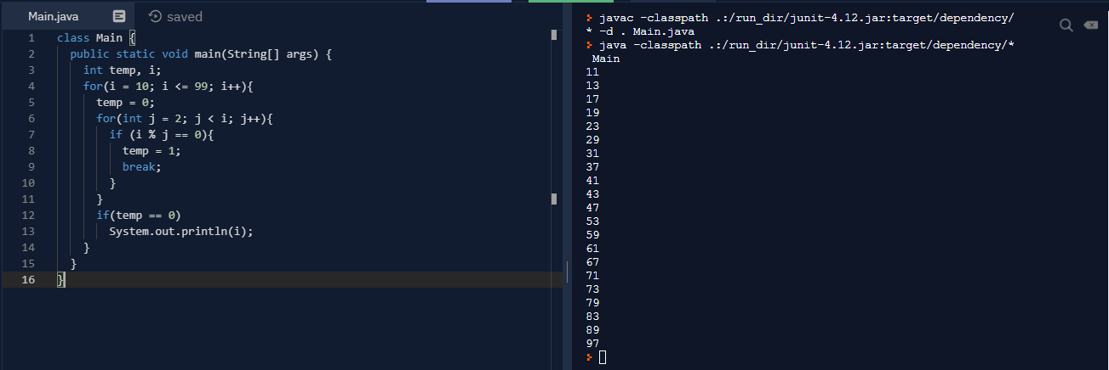

**14.** **Java program to find if the given number is prime or not.**

public class Main {

public static void main(String[] args) {

boolean flag = false;

if (args.length == 0)

System.out.println("Please enter an integer number");

System.exit(0);

int n = Integer.parseInt(args[0]);

if (n == 0 || n == 1)

System.out.println(n + " is neither a prime nor composite");

for(int i = 2; i <= n/2; i++){

if(n % i == 0){

flag = true;

break;

}

}

if(!flag)

System.out.println(n + " is a prime number");

else

System.out.println(n + " is not a prime number");

}

}

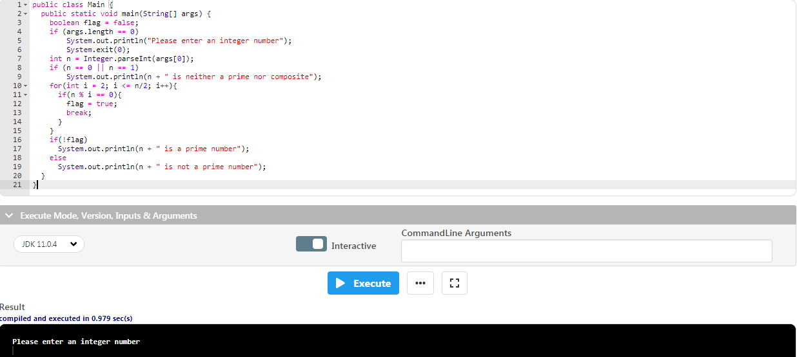

**15.** **Program to add all the values in a given number and print.**

import java.util.*;

class Main {

public static void main(String[] args) {

int rem, val = 0;

Scanner in = new Scanner(System.in);

int n = in.nextInt();

while(n != 0){

rem = n % 10;

val = val + rem;

n = n / 10;

}

System.out.println(val);

}

}

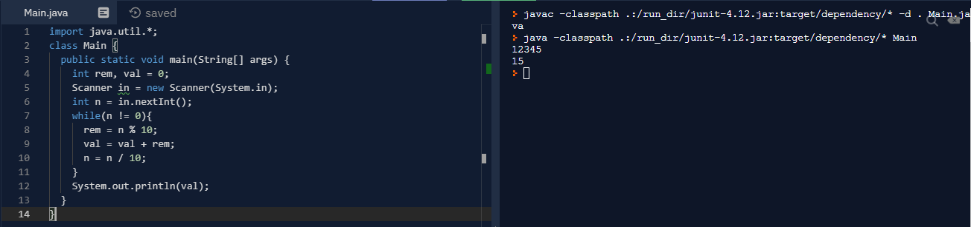

**16.** **Program to print * in Floyds format (using for and while loop).**

public class Main {

public static void main(String[] args) {

int j;

if (args.length == 0)

System.out.println("Please enter an integer number");

System.exit(0);

int n = Integer.parseInt(args[0]);

for(int i = 0; i < n; i++){

j = 0;

while(j <= i){

System.out.print("* ");

j++;

}

System.out.println();

}

}

}

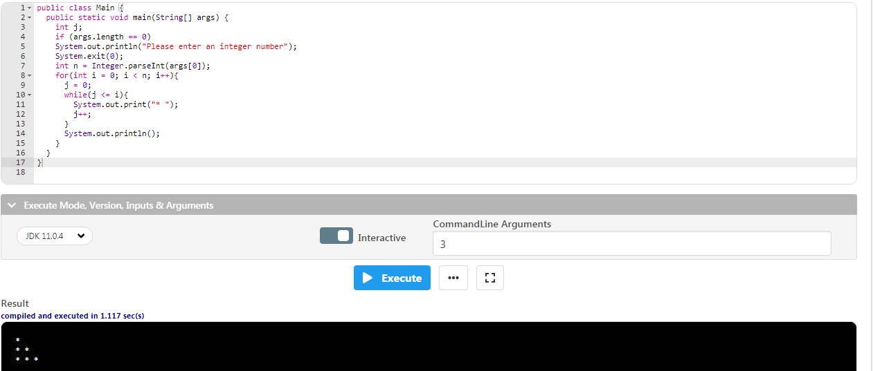

**17.** **Program to reverse a given number and print.**

import java.util.*;

class Main {

public static void main(String[] args) {

int rem, cur = 0;

Scanner in = new Scanner(System.in);

int n = in.nextInt();

while(n != 0){

rem = n % 10;

cur = (cur * 10) + rem;

n = n / 10;

}

System.out.println(cur);

}

}

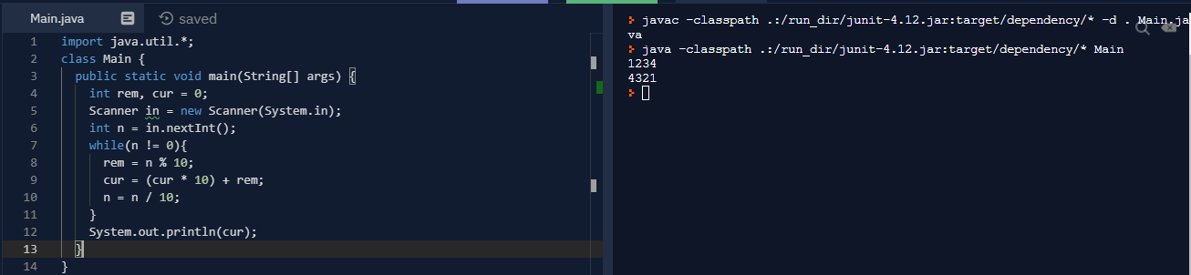

**18.** **Java program to find if the given number is palindrome or not.**

import java.util.*;

class Main {

public static void main(String[] args) {

int rem, cur = 0, temp;

Scanner in = new Scanner(System.in);

int n = in.nextInt();

temp = n;

while(n != 0){

rem = n % 10;

cur = (cur * 10) + rem;

n = n / 10;

}

if(temp == cur)

System.out.println(temp + " is palindrome");

else

System.out.println(temp + " is not palindrome");

}

}

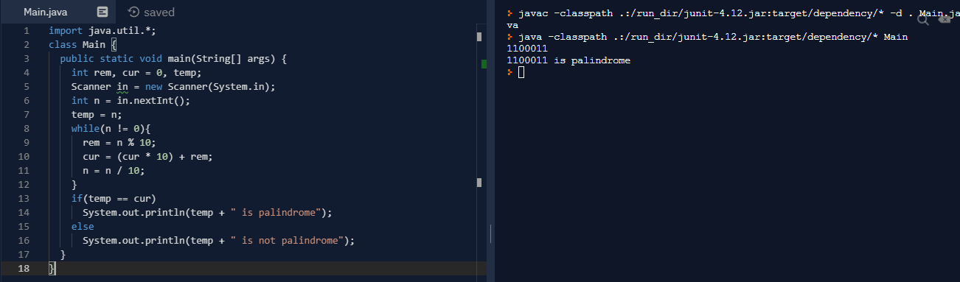

**19.** **Program to print first 5 values which are divisible by 2, 3, and 5.**

class Main {

public static void main(String[] args) {

int count = 0, i = 1;

while(count < 5){

if (i % 2 == 0 && i % 3 == 0 && i % 5 == 0) {

System.out.println(i);

count++;

}

i++;

}

}

}

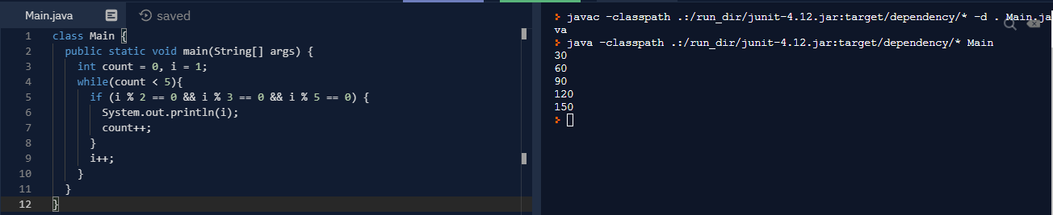

**20.**

import java.util.*;

class Main {

public static void main(String[] args) {

Scanner in = new Scanner(System.in);

int ch, a, b, ans;

char o;

do{

System.out.println("1.Add \n2.Sub");

ch = in.nextInt();

switch(ch) {

case 1: a = in.nextInt();

b = in.nextInt();

ans = a + b;

System.out.println("Sum is " + ans);

break;

case 2: a = in.nextInt();

b = in.nextInt();

ans = a - b;

System.out.println("Difference is " + ans);

break;

}

System.out.println("Do you want to continue");

o = in.next().charAt(0);

}while(o == 'y' || o == 'Y');

}

}

